**Practical No:-** 13

**Roll No.:**15 **Batch-** A **Date of Performance:** 23/03/2024

1. **Write a program to set cookies and read it**

<?php

$cname="Student";

$cvalue="ABC";

setcookie($cname,$cvalue,time()+(86400*30),"/");

?>

<html>

<body>

<?php

if(!isset($_COOKIE[$cname]))

{

echo "Cookie Named".$cname." is not set!";

}

else

{

echo '<script>alert("Cookie is Set")</script>';

echo "Cookie ".$cname." is set!<br>";

echo "Cookie=$cname<br>";

echo "Cookie Value=".$_COOKIE[$cname];

}

?>

</body>

</html>

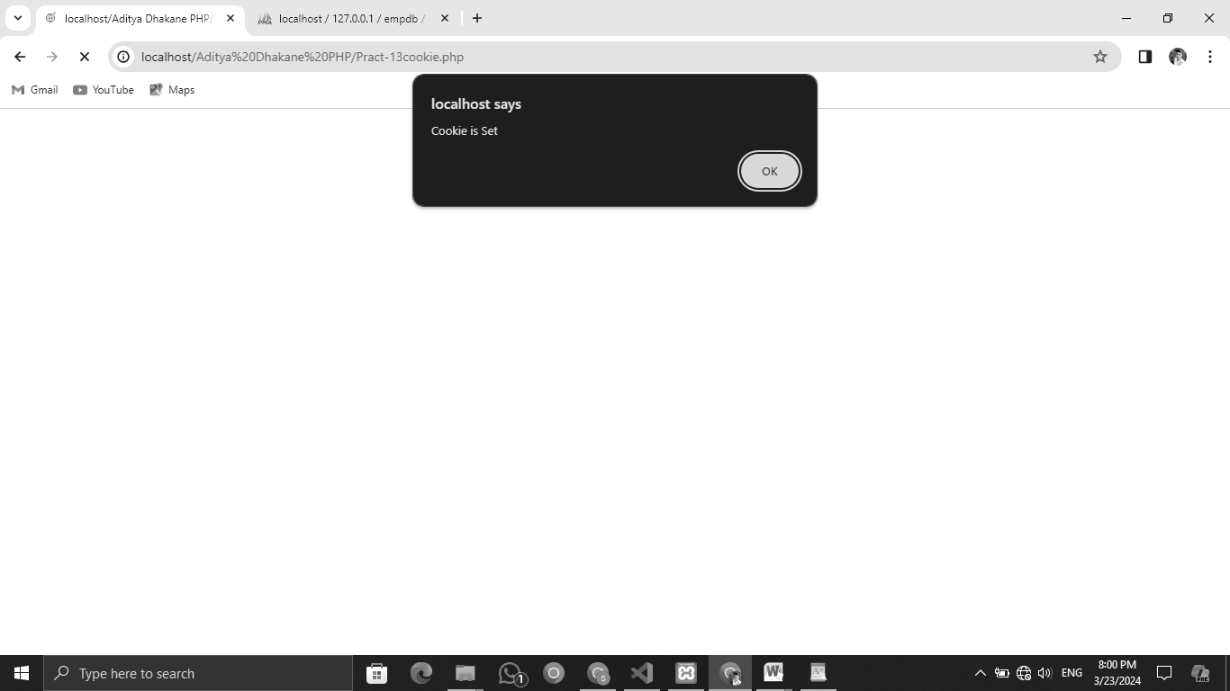

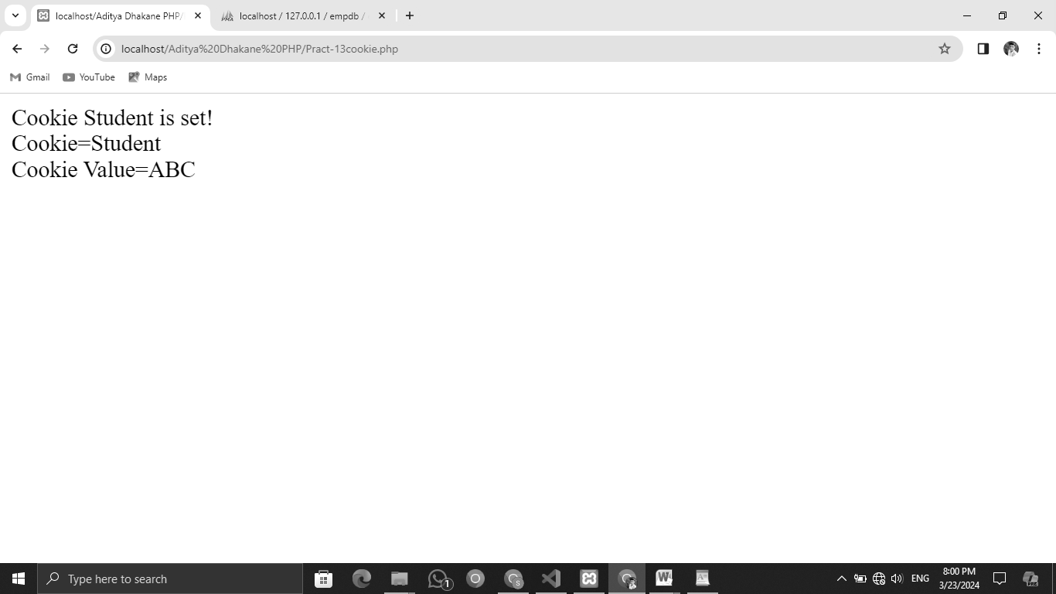

1. **Write a program to demonstrate session management**

<?php

// Start session

session_start();

// Function to set a session variable

function setSessionValue($name, $value) {

$_SESSION[$name] = $value;

}

// Function to get a session variable

function getSessionValue($name) {

if(isset($_SESSION[$name])) {

return $_SESSION[$name];

} else {

return "";

}

}

// Function to delete a session variable

function deleteSessionValue($name) {

unset($_SESSION[$name]);

}

// Handle actions

if(isset($_POST['action'])) {

$action = $_POST['action'];

switch ($action) {

case 'create':

$session_name = $_POST['session_name'];

$session_value = $_POST['session_value'];

setSessionValue($session_name, $session_value);

header("Refresh:0");

break;

case 'delete':

$session_name = $_POST['session_name'];

deleteSessionValue($session_name);

header("Refresh:0");

break;

}

}

?>

<!DOCTYPE html>

<html lang="en">

<head>

<meta charset="UTF-8">

<meta name="viewport" content="width=device-width, initial-scale=1.0">

<title>Session CRUD</title>

</head>

<body>

<h2>Create, Read, Update, Delete Session Variables</h2>

<h3>Create Session Variable</h3>

<form action="" method="post">

Session Name: <input type="text" name="session_name"><br>

Session Value: <input type="text" name="session_value"><br>

<input type="hidden" name="action" value="create">

<input type="submit" value="Create Session Variable">

</form>

<h3>Read Session Variable</h3>

<?php

print_r($_SESSION);

?>

<h3>Delete Session Variable</h3>

<form action="" method="post">

Session Name: <input type="text" name="session_name"><br>

<input type="hidden" name="action" value="delete">

<input type="submit" value="Delete Session Variable">

</form>

</body>

</html>

